**PROJECT DESIGN PHASE-II**

**DATA FLOW DIAGRAM**

|  |  |
| --- | --- |
| Date | 03 October 2022 |
| Team ID | PNT2022TMID13620 |
| Project Name | Corporate Employee Attrition Analytics |
| Maximum Marks | 4 Marks |

**DATA FLOW DIAGRAMS:**

A Data Flow Diagram (DFD) is a traditional visual representation of the information flows within a system. A neat and clear DFD can depict the right amount of the system requirement graphically. It shows how data enters and leaves the system, what changes the information, and where data is stored.

**Example:** [**(Simplified)**](https://developer.ibm.com/patterns/visualize-unstructured-text/)

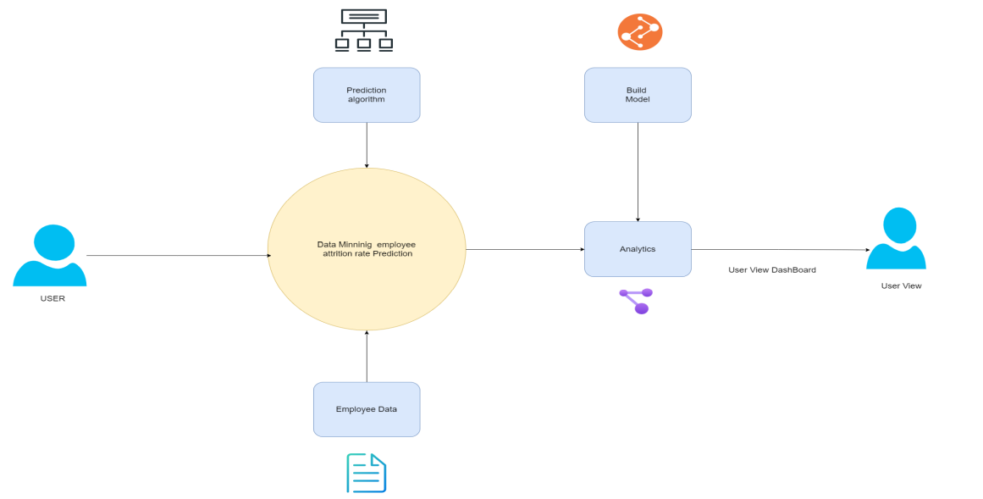

**User Stories**.

| **User Type** | **Functional Requirement (Epic)** | **User Story Number** | **User Story / Task** | **Acceptance criteria** | **Priority** | **Release** |
| --- | --- | --- | --- | --- | --- | --- |
| Customer (Mobile user) | Registration | USN-1 | As a user, I can register for the application by entering my email, password, and confirming my password. | I can access my account / dashboard | High | Sprint-1 |
|  |  | USN-2 | As a user, I will receive confirmation email once I have registered for the application | I can receive confirmation email & click confirm | High | Sprint-1 |
|  |  | USN-3 | As a user, I can register for the application through Facebook | I can register & access the dashboard with Facebook Login | Low | Sprint-2 |
|  |  | USN-4 | As a user, I can register for the application through Gmail | I can register & access the dashboard with Gmail Login | Medium | Sprint-1 |
|  | Login | USN-5 | As a user, I can log into the application by entering email & password | I can access my account / dashboard | High | Sprint-1 |
|  | Dashboard | USN-6 | Uploading the Dataset | I can be able to upload my dataset | High | Sprint 2 |
| Customer (Web user) |  | USN-7 | Working With Dataset | I can be able to access my dashboard | High | Sprint 2 |
| Customer Care Executive |  | USN-8 | Visualization | I can be able to view the visual attrition rate of my dataset | High | Sprint 3 |
| Administrator |  | USN-9 | Working with Dashboard | I can be able to view the various views of the attrition rate | High | Sprint 3 |
|  |  | USN-10 | Asking Help / Feedback | I can be able to ask help if I can face any issues or problems while using the webpage | Medium | Sprint 4 |
|  |  | USN-11 | Managing the Database | I can assure that my data is in secure state | High | Sprint 4 |
|  |  | USN-12 | Managing the over all process | I can assure that my data and process is going good | High | Sprint 4 |